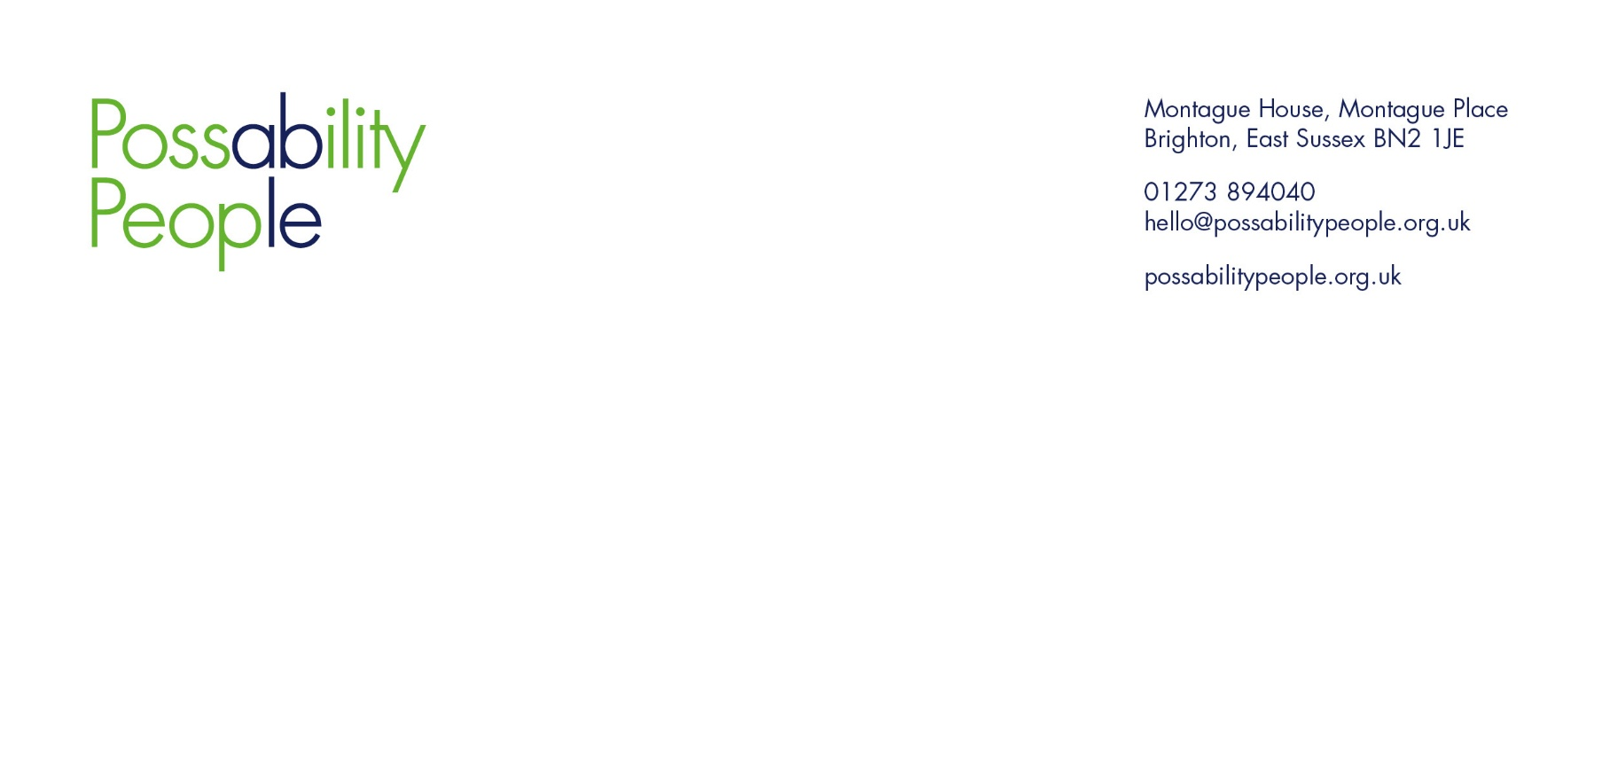

Dear Rt Hon Liz Kendall MP, Secretary of State for Work and Pensions
Response from Possability People to the Department for Work and Pensions' Green Paper: Pathways to Work: Reforming Benefits and Support to Get Britain Working

About Possability People
Possability People is a Brighton based charity that has been supporting disabled people and those living with long-term health conditions, including mental health conditions, for over 40 years. We work across Brighton & Hove and East Sussex, with a mission to support people of all ages and backgrounds to live independently, with dignity and choice.
Through our services, we support thousands of disabled people each year, many of whom are navigating the very benefits and systems being proposed for reform. Our work is grounded in the social model of disability and shaped by the real, lived experiences of our community.
We are deeply concerned about the UK Government’s proposed changes to Personal Independence Payment (PIP), Universal Credit (UC), and Access to Work (AtW). These reforms risk further marginalising disabled people and those with long-term health conditions, many of whom already face systemic barriers to equality and inclusion.
We believe the proposals are based on a fundamental misunderstanding of disability, particularly in relation to fluctuating, invisible, and intersecting conditions. Our response draws on our extensive frontline experience and is co-produced with the very people these reforms will affect.

Lived Experience and Anticipated Impacts
Unfair Assessments and System Failures
Official DWP figures show only 46% of new PIP claims are successful, while 69% of appeals overturn the original decision. In contrast, our Advice Centre achieves an 85% success rate at both the initial and appeal stages demonstrating that DWP is failing to apply its own rules consistently.
Clients with physical disabilities or long-term health conditions often receive 2 points across several Daily Living descriptors, falling short of the 4 points required in any one category.
The system penalises people in employment, with assessments frequently citing work activity as a reason to deny support, even when that work is essential for managing their condition. Our advisors often support individuals whose PIP award was denied or stopped because they were trying to volunteer or work.
Clients have also been penalised for trying to improve their condition and their general wellbeing, for example, one client was denied PIP because they attended the gym twice weekly for 20 minutes on GP advice; this was the only physical activity they could manage.
Access to Work Delays
Delays to AtW are already driving disabled people out of employment. Further restriction or removal of this support will prevent many from entering or remaining in work. The proposal that employers alone should bear the responsibility for reasonable adjustments, without new funding, makes it even less likely disabled people will be hired.
Knock-on Effects on Carers and Family
PIP Daily Living is a gateway to other vital support, including Carer’s Allowance, social housing, and access to services. If someone loses PIP, their carer loses income and may have to find alternative employment, reducing their ability to provide care. The disabled person then loses both formal and informal support, leading to isolation, deterioration in health, and increased demand on already stretched NHS services.
Mental and Physical Health Impacts
The fear of losing essential support is already causing immense anxiety. An Advice Centre survey found that over 50% of respondents sought increased medical support from GPs or the NHS when their benefits were affected. Stress, uncertainty, and financial insecurity all exacerbate existing health conditions.
Economic Impact
Disabled people spend their benefits locally, thus supporting small businesses, services, and independent traders. Cuts to benefits reduce this spending power and harm the local economy. The loss of 'purple pound' circulation will be felt widely.
Intersecting Identities and Regional Disparities
People from racialised communities, migrants, and LGBTQ+ individuals face additional barriers to accessing support due to cultural, linguistic, or systemic discrimination. These groups are less likely to appeal unfair decisions and more likely to experience poor outcomes.
In areas like East Sussex, inaccessible transport continues to isolate disabled people from employment and community life. The proposed reforms do not acknowledge such structural barriers, nor the compounded exclusion faced by older disabled people who are routinely shut out of the workforce.
Digital Exclusion
Many claimants are digitally excluded, lacking smartphones, computers, or reliable broadband. Digital-by-default systems leave behind those who cannot engage online due to poverty, age, or disability. This is not a matter of preference but of basic access to support. Clients report delays of over three months for a DWP home visit to verify ID for UC migration, during which they survive on food banks and family loans.

Spending Breakdown (Advice Centre survey - 100 respondents):
- 85% spend PIP on care and support needs
- 40% use it for private/alternative therapies recommended by NHS
- 20% use it to cover other daily costs of managing their condition

Gaps and Flawed Assumptions in the Reform Proposals
Binary Thinking on Work Capability
The reforms rely on an outdated ‘fit for work’ or ‘not fit’ binary that fails to reflect the real-life fluctuations many disabled people experience. This leads to unfair assessments and inaccurate conclusions about someone’s ability to work.
Inaccessible Assessments
Assessments remain overly reliant on rigid face-to-face or online formats that do not capture real-world impact. There is also no strategy to address the ongoing crisis in digital exclusion, particularly among older people.
No Funding Increase for Access to Work
The proposals offer no additional investment in Access to Work. Instead, the burden is shifted onto employers, many of whom are already reluctant to recruit disabled staff. Without this support, disabled employees will struggle to sustain work, contradicting the aim of increasing employment participation.
Young People and Under-22s at Risk
There is growing concern over how changes will affect disabled young people, especially those who received DLA as children. Many are in non-advanced education, living at home, and no longer eligible for support through their parents’ claims, yet now appear barred from claiming in their own right. Families are being placed in impossible positions, potentially having to sever financial ties with their vulnerable child for them to receive basic support.

What’s Missing:
- No meaningful engagement with Disabled People’s Organisations (DPOs).
- No specific protections for people facing intersecting disadvantage, such as disabled people who are also racialised, LGBTQ+, neurodivergent, or carers.
- No clear evidence base for the reforms, and delayed publication of the Equality Impact Assessment.

Potential Risks:
- Increased poverty, destitution, and mental health crises, with a potential rise in deaths by suicide.
- Greater pressure on already stretched local services and voluntary sector organisations, without corresponding financial support.
Unrealistic Burden on Disabled People The proposals place the onus on disabled individuals to become ‘work ready’, but in reality, it is often organisations and workplaces that are not ready. Our members repeatedly tell us that it is not their impairments that prevent them from working it is inaccessible recruitment practices, inflexible work environments, and a lack of understanding and support.

Outdated Thinking Has No Place in 2025
Reforms that ignore this structural barrier risk blaming individuals for systemic failure, this approach reflects an outdated, medicalised view of disability that belongs in the mid-20th century. In 2025, we should not be returning to models that blames the individual while ignoring inaccessible systems and environments. Modern disability rights frameworks and decades of progress tell us that it is society that must adapt, not the other way around.

Priorities and Solutions

The Priorities should be:
Recognising that reducing benefits does not equate to increasing employment. Employment outcomes for disabled people are shaped far more by structural inequality, discrimination, and inaccessible systems than by individual motivation.
Acknowledging the real-life, long-term consequences of removing financial independence. Without adequate income, people cannot access safe housing, healthcare, food, or even the internet, all essential for participation in work or society.
Placing lived experience and co-production at the heart of reform. Only policies shaped with and by disabled people can be trusted to meet real needs and avoid replicating the exclusion of past systems.

Alternative Solutions:
- Reform assessments to be functional, holistic, and co-designed with DPOs.
- Create protections for people at the intersection of disability and other marginalisation.

Good Practice Model – New Zealand- Enabling Good Lives
New Zealand’s person-led disability support models, which prioritise individual choice and control. Their system operates on the principle of 'Enabling Good Lives,' allowing disabled people to design their own support plans with funding that follows the person, not the service. This approach shifts power away from bureaucratic systems and towards the lived experience of the individual.
It includes personal budgets, co-designed services, and flexible support arrangements, all of which are tailored to the goals and preferences of the disabled person, promoting independence, dignity, and long-term wellbeing.

You Can’t Punish People into Work
These reforms will not incentivise work, they will entrench inequality and deepen exclusion. Disabled people are not asking for special treatment; they are asking for the same things everyone else wants - fair access, autonomy, and dignity. Access to employment and support is not a privilege to be earned; it is a right, grounded in both human rights principles and the Equality Act 2010.
The proposed changes fail to recognise that the real barriers to employment for disabled people lie not within individuals, but within the systems that exclude them. Inaccessible transport, discriminatory recruitment processes, digital exclusion, inconsistent support, and inflexible workplaces all create structural disadvantages that no amount of personal motivation can overcome.
Forcing disabled people to prove their "work readiness" by threatening to withdraw support does not improve outcomes, it increases anxiety, erodes trust in public services, and undermines people’s ability to engage in meaningful activity. These proposals imply that disabled people need to be pressured or punished into employment, rather than supported and empowered. This approach is not only ineffective, but also fundamentally unjust.
Employment participation will only improve when systemic barriers are removed. This means investment in inclusive infrastructure, reforming inaccessible systems, holding employers to account for discrimination, and ensuring that support like Access to Work is timely, sufficient, and universally accessible.
Unless the government shifts its focus from individual compliance to systemic reform, any efforts to ‘incentivise’ work will continue to penalise those already furthest from the labour market, pushing them into poverty, mental distress, and social isolation, not employment.

Conclusion
The government’s proposed reforms to PIP, Universal Credit, and Access to Work risk undermining decades of progress towards disability equality. These are not simply administrative changes, they represent a fundamental rollback of rights, autonomy, and support that disabled people rely on to live independently and with dignity.

At Possability People, we are proud to stand alongside disabled people every day. We know from experience that meaningful inclusion begins with listening, not imposing. These proposals must be paused. Instead, we call on the government to co-produce a new, fairer approach: one that is rooted in lived experience, shaped by Disabled People’s Organisations, and committed to removing the systemic barriers that prevent participation in work and society.
Without this shift, the reforms will not incentivise employment or promote independence. They will deepen exclusion, increase poverty, and push disabled people further to the margins - socially, economically, and politically.
We would welcome the opportunity to engage further and share the insights of our community in any future review, consultation, or redesign of these proposals.
Kind Regards,

Lucy Vallis - Chief Executive Officer

Questions for the Secretary of State for Work and Pensions
To support transparency, evidence-led policy, and genuine co-production, we respectfully ask the Secretary of State to respond to the following questions raised through our community engagement and frontline experience:

- What evidence does the Government have that reducing financial support leads to increased employment among disabled people?
- How will the DWP ensure that assessments account for fluctuating and invisible conditions, and are not based solely on snapshots or appearance during a single assessment?
- How does the Government intend to address the current delays in Access to Work, and what investment is being made to scale the scheme alongside its proposed reforms?
- Why was the Equality Impact Assessment not published at the same time as the Green Paper, as required under the Public Sector Equality Duty? Will the full report (including methodology and disaggregated data) be made available for scrutiny?
- What mitigation measures does the Department intend to introduce in response to its own Equality Impact Assessment, which shows that 20% of households including a disabled person will lose income under these proposals?
- What specific analysis has been undertaken to understand the intersectional impact of the proposed reforms on disabled people who are also:
- unpaid carers,
- from racialised communities,
- LGBTQ+,
- neurodivergent, or
- living with serious mental illness?
- How will the Department ensure that reforms do not disproportionately affect disabled people already experiencing multiple forms of systemic disadvantage, including those living in rural or digitally excluded areas?
- How will the Government commit to genuine co-production going forward?
- What safeguards will be introduced to prevent adverse effects on disabled children, young people in education, and their families?
- How will the Government support employers, particularly SMEs, to deliver reasonable adjustments if Access to Work is reduced or delayed?
- What specific steps is the DWP taking to reduce the high rate of overturned PIP decisions at tribunal, and how will future assessments ensure fairness?
- What monitoring and accountability mechanisms will be put in place to ensure that the reforms do not increase poverty, destitution, or mental health crises?

For more information, please contact: hello@possabilitypeople.org.uk

