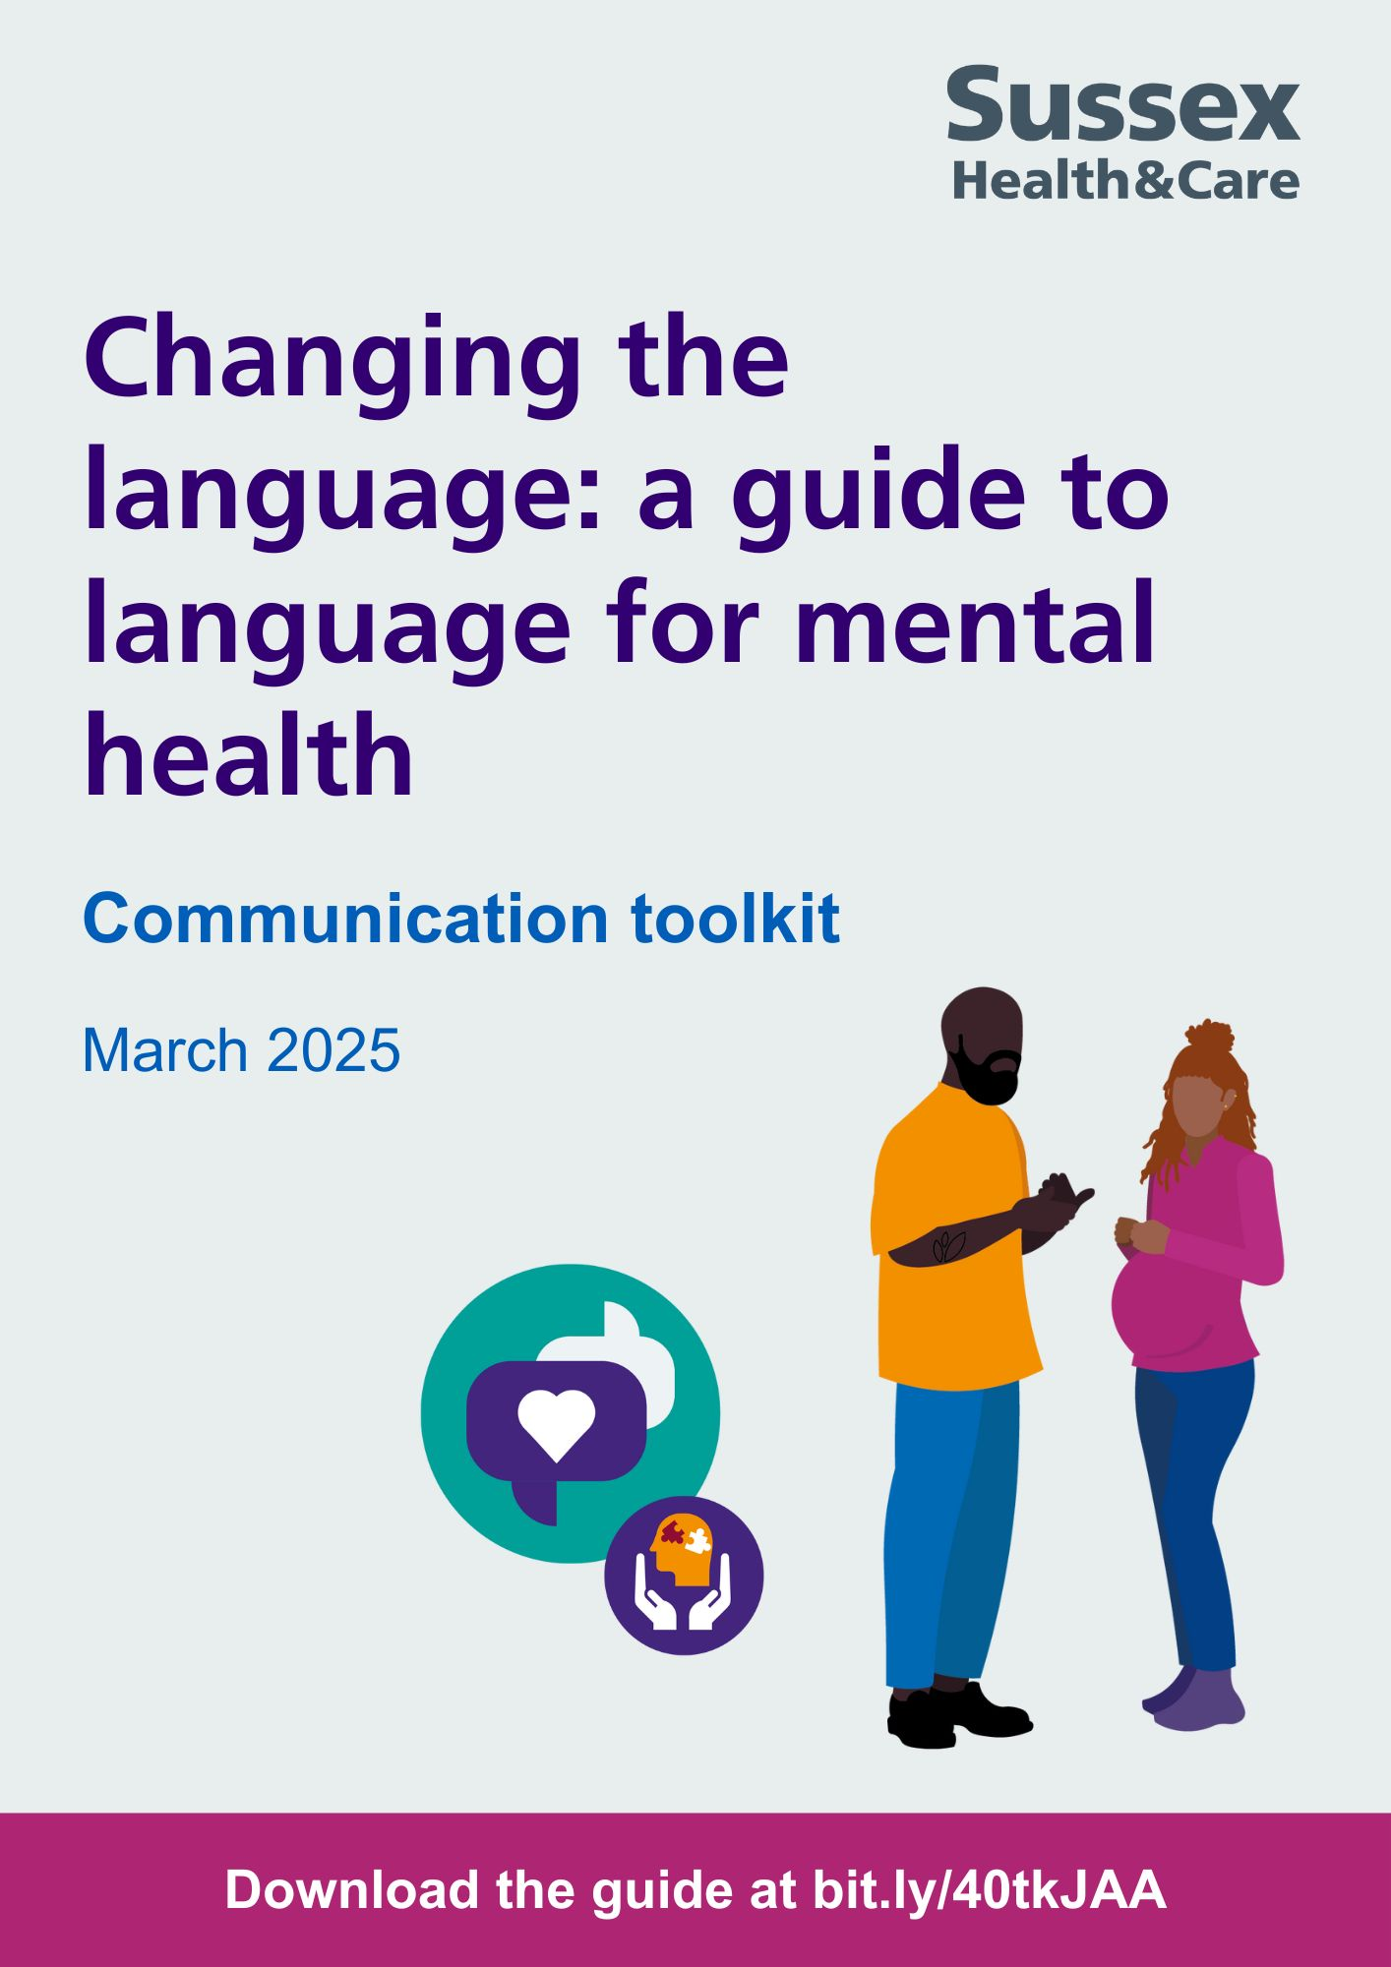

**Contents**

1. Changing the language: a guide to mental health language 2

Developing a guide 2

Who the guide is for, and how it should be used 3

2. Sharing the guide 3

Printed materials 3

Digital screens and screensavers 3

Social media 3

Intranet story and staff newsletters 4

About the Mental Health Language Reference Group 5

Contact us 5

# Changing the language: a guide to mental health language

A new guide has been developed to help encourage positive conversations and an improved understanding of the impact that language, words and phrases can have on people when they are accessing mental health support.

Launched by Sussex Health and Care, a partnership of organisations across Sussex, the ['C*hanging the language: a guide to language for mental health'*,](https://www.sussex.ics.nhs.uk/wp-content/uploads/sites/9/2025/01/Changing-Language-Guide-2025_28_01_25_Interactive.pdf) has been coproduced by people with an interest in supporting a positive change of the language we use. This has included people with lived and living experience of mental health difficulties and using services, experts by experience, families and carers, and people working in health and care services across Sussex.

## **Developing a guide**

Originating as part of the [community mental health transformation programme in Sussex](https://www.sussex.ics.nhs.uk/our-work/our-priorities/mental-health-learning-disability-and-autism/mental-health/community-mh-transformation/), the Mental Health Language Reference Group was formed to provide a forum for further learning and resources to be developed.

The group has written the guide together which brings together local learning and feedback from over 100 people that have been involved in the work throughout the last two years.

To find out more, please email [spft.communitytransformation@nhs.net](mailto:spft.communitytransformation@nhs.net).

## **Who the guide is for, and how it should be used**

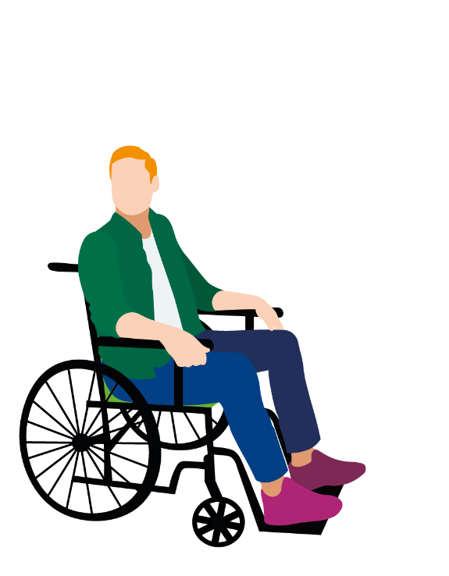The aspiration is that the guide will be used in conversations, workplace meetings, clinical appointments, and staff training. The guide does not provide a list of do's and don’ts, but instead offers suggestions of things we can all do to be more aware of the language we use.

As well as mental health language, the guide also provides guidance on communicating with specific groups of people, including people who speak English as an additional language or do not speak English, people who have accessibility needs and/or a disability, and people who are neurodivergent.

Throughout the guide there are also references to other useful resources and guidance to help support learning.

# Sharing the guide

## **Printed materials**

We have developed a poster and a 'top 10 tips' version of the guide, both of which direct people to view the full version of the guide online.

You can download and print these locally, or if you would like printed versions sent to you, please email: [spft.communitytransformation@nhs.net](mailto:spft.communitytransformation@nhs.net).

* [Download poster](https://drive.google.com/file/d/1q1uLw6TlwIqNjaKp0ciD-CsZVdtfSuDO/view?usp=sharing)
* [Download 'top 10 tips' double-sided flyer](https://drive.google.com/file/d/1Um3f0qxwbELADQ1sD6OVlOws4T2OY0RQ/view?usp=sharing)

## **Digital screens and screensavers**

We have developed some graphics to be used on digital screens/televisions and screensavers. If you have access to these in your locations, for example GP surgeries, we would appreciate it if you can please display these.

* [Download digital screen graphic](https://drive.google.com/file/d/1-RiKwTBr2pHSzTxC-iYocLcRY3kNh9hr/view?usp=sharing)

## **Social media**

We have developed a range of example social media posts and graphics which you can use on your organisational social media channels. Please use these posts from **Thursday 6 March 2025.**

You can also help support the launch of the guide by liking and resharing posts shared by other colleagues and using the hashtag **#ChangingTheLanguage**.

**Making social media accessible**

Please use image description and alt text to make your social media accessible for blind and partially sighted people. Please refer to the [RNIB's accessibility checklist](https://drive.google.com/file/d/1vZhRUt89q7o-rLYF82ZKvlwM37wwRE3H/view?usp=drive_link) for guidance.

* [Social media graphics - X, Facebook and Bluesky](https://drive.google.com/drive/folders/1A9z_plNYwfbeiwNPclB38uYfcPZr3DMt?usp=drive_link)
* [Social media graphics - Instagram](https://drive.google.com/drive/folders/1FBNl4VCU3vBg_AUyEV_KZT6tc1Ou55hB?usp=drive_link)

|  |  |
| --- | --- |
| **Post copy** | **Graphic** |
| A new guide has been launched to help encourage positive conversations and an improved understanding of the impact that language, words and phrases can have on people when they are accessing mental health support #ChangingTheLanguage | **Facebook, X, Bluesky and LinkedIn:** [Choose a graphic](https://drive.google.com/drive/folders/1A9z_plNYwfbeiwNPclB38uYfcPZr3DMt?usp=drive_link)  **Instagram:** [Choose a graphic](https://drive.google.com/drive/folders/1FBNl4VCU3vBg_AUyEV_KZT6tc1Ou55hB?usp=drive_link) |

## **Intranet story and staff newsletters**

Another way that you can help to promote the launch of the language guide is through your internal staff channels, including staff intranet and staff newsletters. Please see below an example of a message you can use:

**Changing the language: a guide to mental health language**

A new guide has been developed to help encourage positive conversations and an improved understanding of the impact that language, words and phrases can have on people when they are accessing mental health support.

Launched by Sussex Health and Care, a partnership of organisations across Sussex, the 'C*hanging the language: a guide to language for mental health'*, has been coproduced by people with an interest in supporting a positive change of the language we use. This has included people with lived and living experience of mental health difficulties and using services, experts by experience, families and carers, and people working in health and care services across Sussex. The group has written the guide together which brings together local learning and feedback from over 100 people that have been involved in the work throughout the last two years.

The 'C*hanging the language: a guide to language for mental health'* is now available at: [www.sussex.ics.nhs.uk/wp-content/uploads/sites/9/2025/01/Changing-Language-Guide-2025_28_01_25_Interactive.pdf](http://www.sussex.ics.nhs.uk/wp-content/uploads/sites/9/2025/01/Changing-Language-Guide-2025_28_01_25_Interactive.pdf).

If you have any questions or would like to get involved in this project, please email [spft.communitytransformation@nhs.net](mailto:spft.communitytransformation@nhs.net).

## **About the Mental Health Language Reference Group**

The Mental Health Language Reference Group is a collaboration of NHS, VCSE, and people with lived/living experience. The following organisations are members of the reference group and contributed to the development of the changing the language guide:

* BHT Sussex
* Capital
* NHS Sussex
* People Participation Team
* Possability People
* Southdown
* Sussex Coproduction and Lived Experience (SCALE) Network
* Sussex Health and Care
* Sussex Interpreting Services
* Sussex Partnership NHS Foundation Trust
* West Sussex County Council
* West Sussex Mind

**Contact us**

To find out more about this project or to join the Mental Health Language Reference Group, please email [spft.communitytransformation@nhs.net](mailto:spft.communitytransformation@nhs.net).

