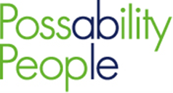 ASK THE EXPERTS
Do you have lived experience of multiple long-term health conditions? Do you want to have your voice heard regarding your experiences with the NHS. If so, then we would really like to work with you on our Ask the Experts project.
People with multiple diagnoses have a unique view of the NHS and how different services work together, or not, to support people and this is why we want to involve you and ensure that you can feedback to the NHS on what worked well, what hasn’t worked well and most importantly how this can be improved for the future.
We will be hosting user-led workshops and forums over the next year and at some of these meetings we will have representatives from the NHS who want to hear directly from you. The sessions will take place online and we can discuss your accessibility needs and signpost you to some support for these if needed.
This is a great opportunity for you to share your experiences with providers, giving advice, guidance and innovative ideas for improvement, and shaping future provision of services. All those participating will receive a high street shopping voucher for each session they attend.
For further information please contact Graeme Trelford-Davies - Engagement & Inclusion Lead on 07712 524 892 or email graeme@possabilitypeople.org.uk.

