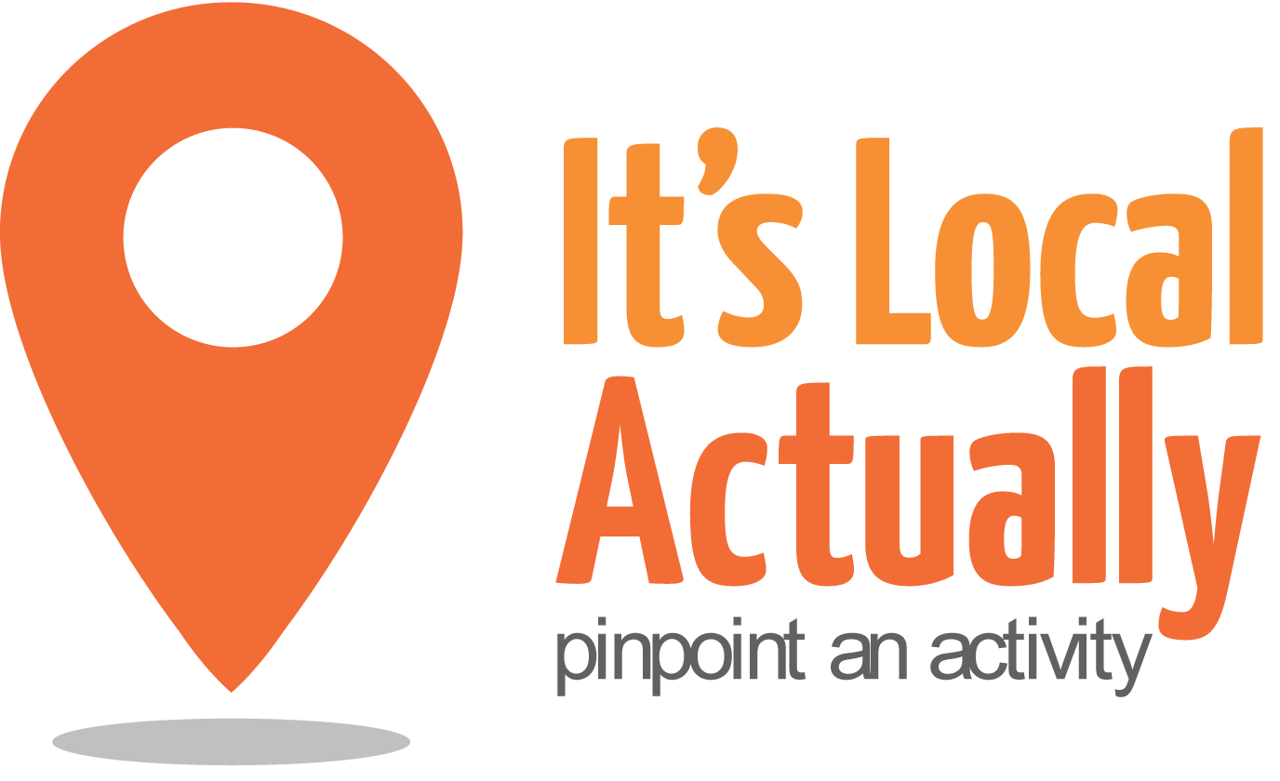

Citywide Connect Programme Board
24 January 2018 10am – 1pm (with working lunch)
Jubilee Library (Conference Room 3), Jubilee St, Brighton BN1 1GE
Agenda

 | Item | Presented by | Paper and Status | Timing
1 | Arrivals/Tea & Coffee |  |  | 10.00
2 | Welcome, introductions and apologies | Geraldine Desmoulins |  | 10.10
3 | Notes from last meeting | Geraldine Desmoulins | Paper 1 | 10.15
4 | Citywide Connect Programme Update  - Autumn 2017 Locality Hub Events  - Q&A  - Funding 2018/19 | Tracey Maitland/ Citywide Team | Discussion/ agreement | 10.20
5 | Public Health Update  - Prevention plan/Caring Together  - Influence of CWC and engaging other directorates | David Brindley  All | Update/  Discussion/ | 10.50
6 | CPJ Field  - Business overview /’whole process’ approach  - Reflections on Locality Hubs and preventing loneliness in Brighton & Hove  - Q&A | Charlie Field | Discussion/  Actions | 11.05
7 | Partner round up  - Your updates and offers/needs related to transitions | All | Discussion/  Actions | 11.25
8 | Working lunch  10 mins to get food before next item |  |  | 12.25
9 | Food Strategy Action Plan Refresh/Bid for Gold  - How can you contribute to achieving this aim?  - What barriers do you think need overcoming?  - Do you have any other suggestions which should go under this aim? | Emily O’Brien | Discussion/  Actions | 12.35
10 | A.O.B. | Geraldine Desmoulins |  | 12.55
11 | CLOSE |  |  | 13.00
NEXT Meetings 2018
Wednesday 28th March 2018

