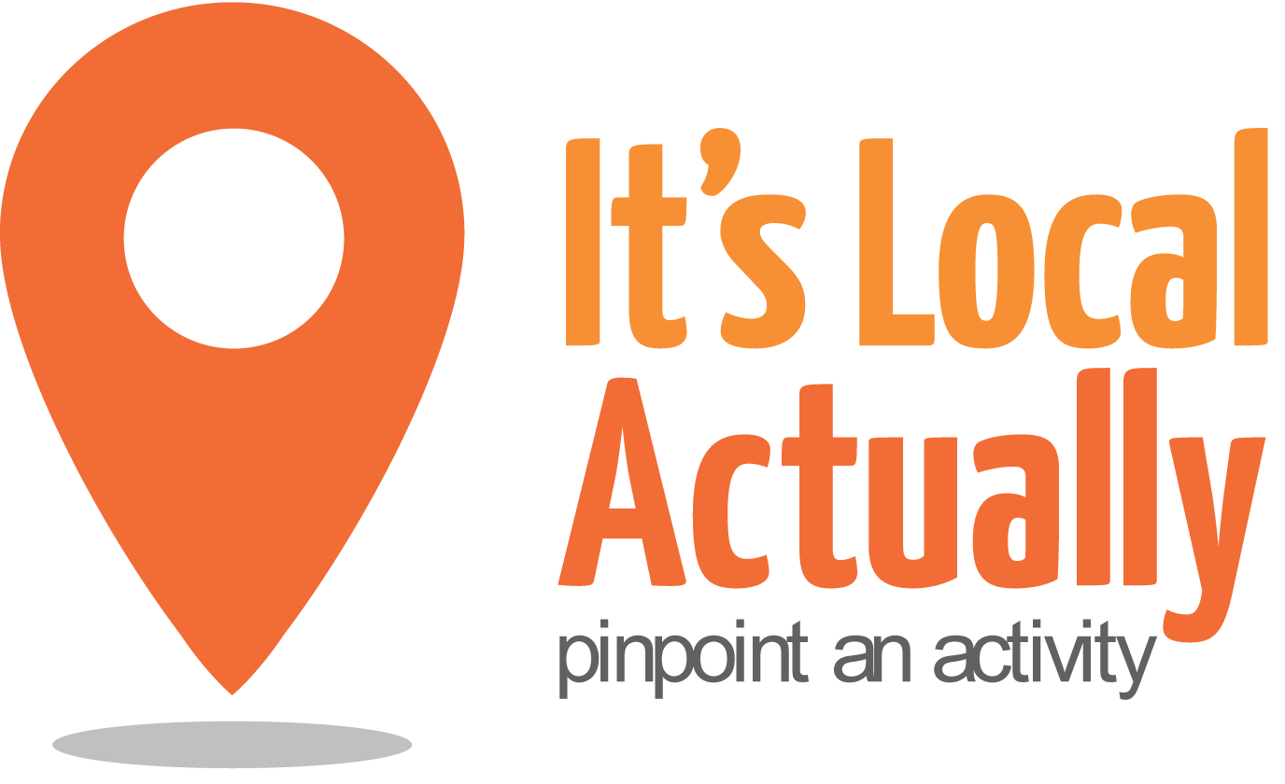

Citywide Connect Programme Board
23rd March 2017 10am – 1pm (with working lunch)
Hove Fire Station, English Close, Hove, BN3 7EE

Agenda
 | Item | Presented by | Paper and Status | Timing
1 | Arrivals/Tea & Coffee |  |  | 09.45
2 | Welcome, introductions and apologies | Geraldine Desmoulins |  | 10.00
3 | Notes from last meeting | Geraldine Desmoulins | Paper 1 | 10.05
4 | Spring 2017 Locality Hub Events  - Evaluation  - Challenges, gaps, solutions  - Q&A | Tracey Maitland/ Citywide Team | Discussion/ agreement | 10.20
5 | Partner round up  - Your updates | All | Discussion/  Actions | 11.00
6 | Citywide Connect – recommission  - Intentions/priorities | All | Discussion/  Actions | 11.30
7 | Working lunch  10 mins to get some food before next item |  |  | 12.00
8 | Preventing vulnerability - transition points/risks  - What strategically already helps with this?  - What else structurally can be done to minimise the risks?  - How CWC can help? | All | Discussion/  Actions
9 | A.O.B. | Geraldine Desmoulins |  | 12.55
10 | CLOSE |  |  | 13.00
NEXT Meetings 2017
Thursday 7th September 2017
Wednesday 6th December 2017

