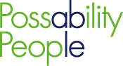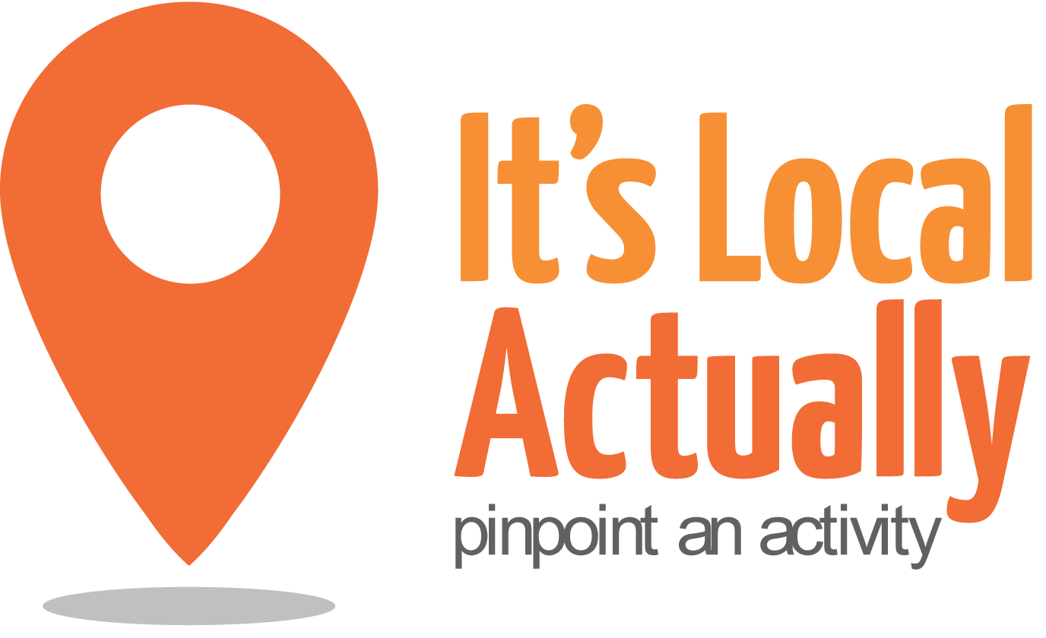

Citywide Connect Programme Board
Ralli Hall, Hove, BN3 3TH
12th December 2016 10am – 12pm (with optional lunch)

Agenda
 | Item | Presented by | Paper and Status | Timing
1 | Arrivals/Tea & Coffee |  |  | 09.45
2 | Welcome, introductions and apologies | Geraldine Desmoulins |  | 10.00
3 | Notes from last meeting | Geraldine Desmoulins | Paper 1 | 10.05
4 | Programme Update  - Evaluation launch  - Autumn 2016 hubs – bookings/action groups | Keith Beadle  Citywide Team | Discussion/ comment  Paper 2  Discussion/ comment | 10.20
5 | Befriending and social prescribing update | Jane Lodge | Information | 10.40
6 | Working groups  - Who or what could we influence and how? | All | Discussion/  Actions | 10.50
7 | Information share | All |  | 11.40
8 | A.O.B. | Geraldine Desmoulins |  | 11.55
9 | CLOSE |  |  | 12.00
 | Lunch - optional
NEXT Meetings 2016
Tuesday 28th February 2017
Tuesday 23rd May 2017
Thursday 7th September 29017
Wednesday 6th December 2017

