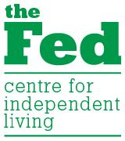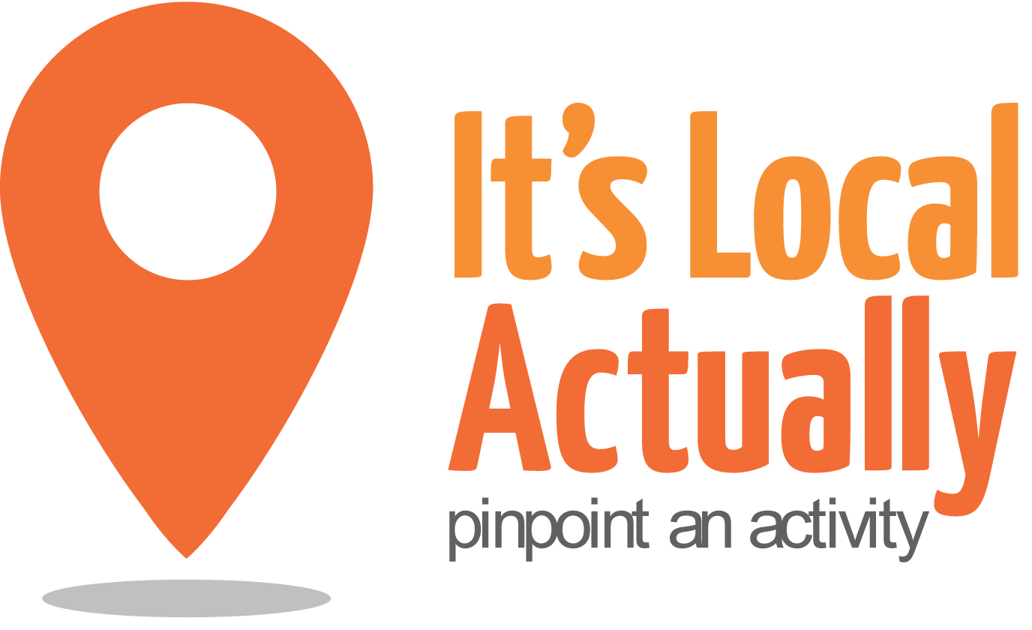

Citywide Connect Programme Board
Open Market, Marshalls Row, Brighton, BN1 4JU
2nd February 2016 10am – 1pm (with working lunch)

Agenda

 | Item | Presented by | Paper and Status | Timing
1 | Arrivals/Tea & Coffee |  |  | 10.00
2 | Welcome, introductions and apologies | Geraldine Desmoulins |  | 10.15
3 | Notes from last meeting | Geraldine Desmoulins |  | 10.20
4 | Programme Update  - Hub feedback & headlines/pledges  - Workstream update  - Hubs agenda Spring 2016 | Keith Beadle  Citywide Team | Discussion/ comment  Papers 1 & 2 | 10.30
5 | Partners Showcase (1)  - Linking with PPGs  - Questions | Jenny Moore | Information/  discussion | 11.10
5 | Partners Showcase (2)  - Self- management: Right Track pilot  - Questions | Emma Field | Information/  discussion | 11.25
7 | SECAMB  - Falls Prevention & Community Links | Tom Pullen/Annie Alexander | Information/  discussion | 11.40
8 | Working Lunch  10 mins to get some food before next item |  |  | 12.00
11 | Working Groups  - Update on Strategy, Monitoring and  Evaluation Framework  - Review of outcomes | Judith Cousin/All | Information/  discussion | 12.10
12 | Partners Action Pledges – update  - Information Share | All |  | 12.45
13 | A.O.B. | Geraldine Desmoulins |  | 12.55
14 | CLOSE |  |  | 13.00
NEXT Meetings 2016
Tuesday 7th June
Wednesday 7th September
Tuesday 6th December

