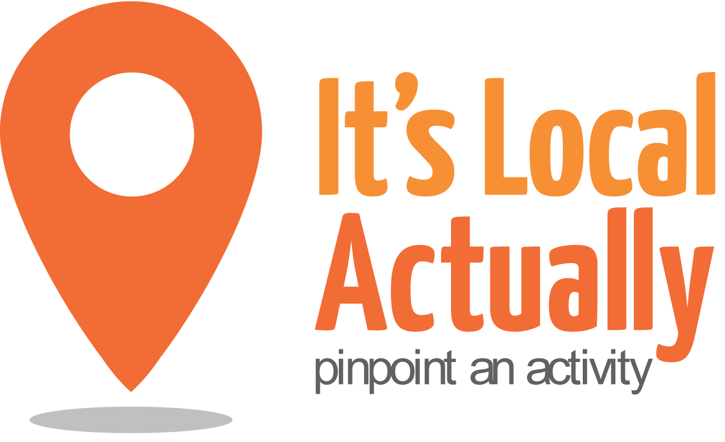

Citywide Connect Programme Board
1 November 2017 2017 10am – 1pm (with working lunch)
Lighthouse, Conference Room, 28 Kensington Street, BN1 4AJ
Agenda

 | Item | Presented by | Paper and Status | Timing
1 | Arrivals/Tea & Coffee |  |  | 09.45
2 | Welcome, introductions and apologies | Geraldine Desmoulins |  | 10.00
3 | Notes from last meeting | Geraldine Desmoulins | Paper 1 | 10.05
4 | Citywide Connect Programme Update  - Outreach and engagement activity  - Digital resources update  - Autumn 2017 Locality Hub Events  - Q&A | Tracey Maitland/ Citywide Team | Discussion/ agreement | 10.15
5 | Digital Brighton and Hove  - Overview of Project  - Role of digital inclusion in later life  - Q&A | Richard Denyer-Berwick | Discussion/  Actions | 10.35
6 | Partner round up  - Your updates | All | Discussion/  Actions | 10.55
7 | Working lunch  10 mins to get food before next item |  |  | 11.55
8 | Caring together Care Programme 1  - Your views on Project 1A: Preventative Services and Citywide Connect’s role within this | All | Discussion/  Actions | 12.05
10 | A.O.B. | Geraldine Desmoulins |  | 12.55
11 | CLOSE |  |  | 13.00
NEXT Meetings 2017
Wednesday 24th January 2018

