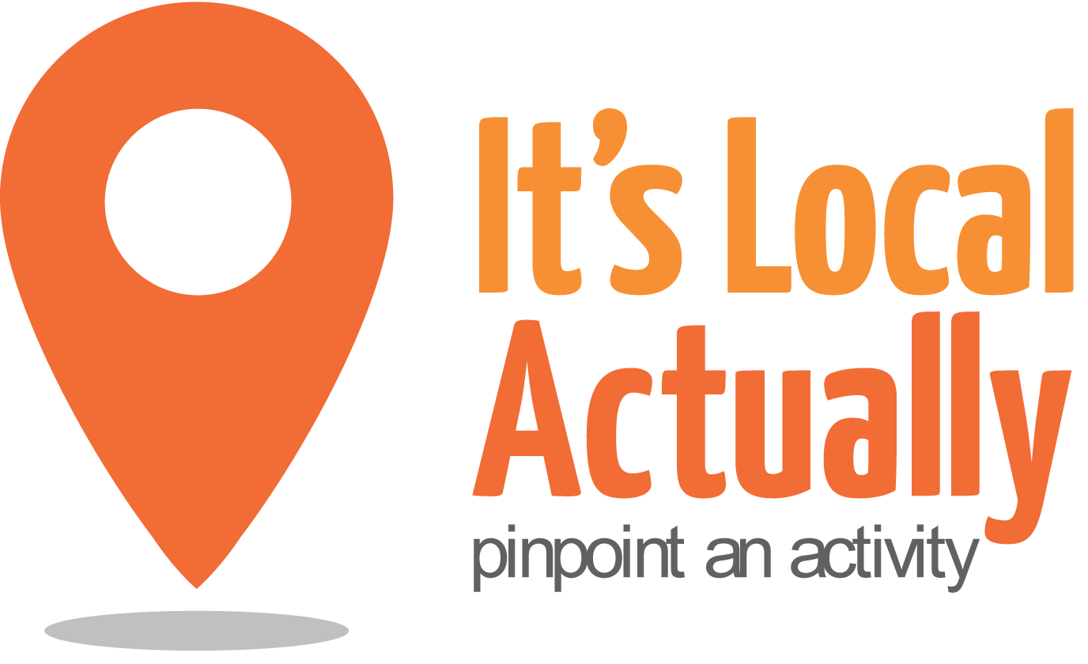
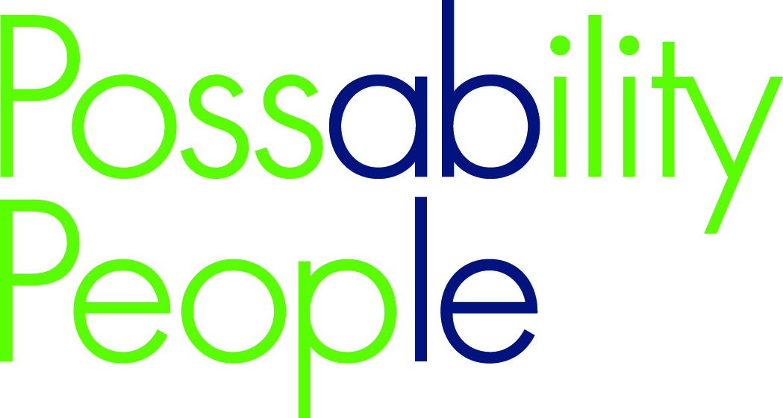

Citywide Connect Programme:

Locality Hub Events

Autumn 2016

10.00am – 2.30pm (with working lunch)

09.45 Arrivals

10.00 Welcome and introductions / updates

10.35 Getting to know you

10.45 Working groups:
    - Understanding locality profiles for your area and risk factors
    - Identifying gaps

12.15 Lunch/networking

1.00 Working groups
- Bringing it all together - tackling the gaps and preventing risk

2.15 Next steps
Monitoring and Evaluation

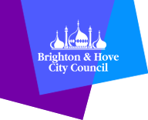
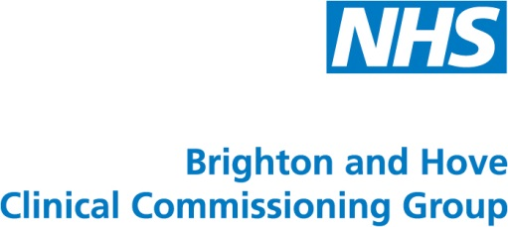
2.30 Close

