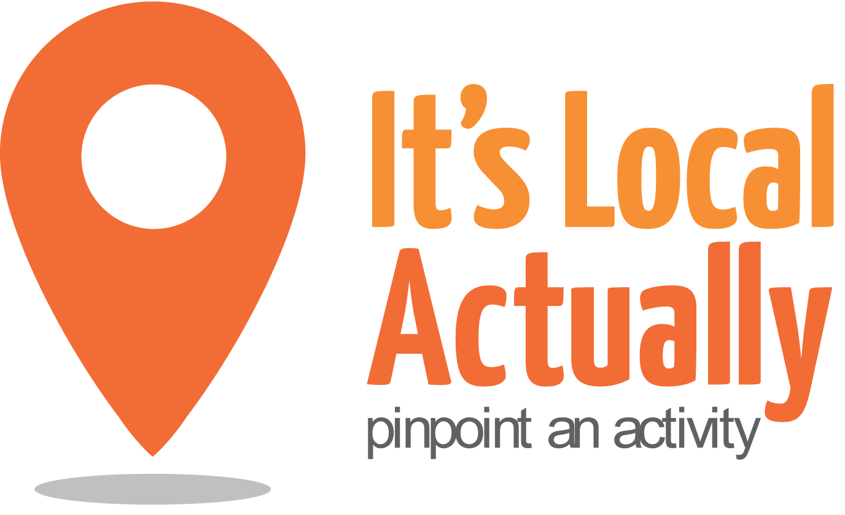
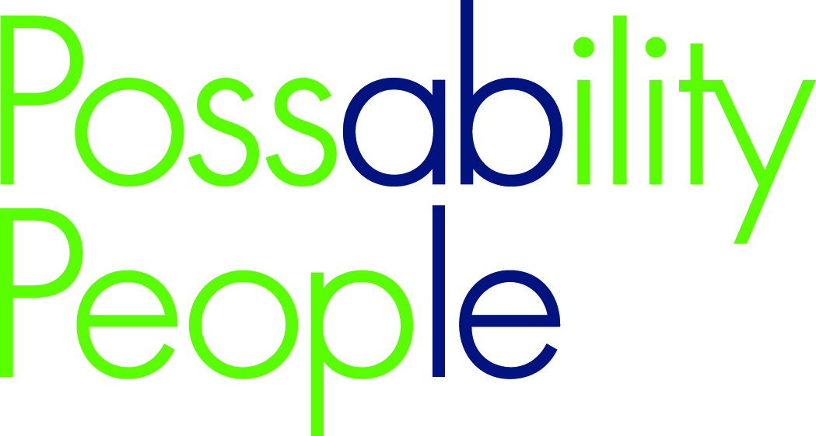

Citywide Connect Programme:

Locality Hub Events

Autumn 2016

10.00am – 2.30pm (with working lunch)

09.45 Arrivals

10.00 Welcome and introductions / updates

10.20 Getting to know you

10.40 Showcases and Q&A

11.20 Working groups
Identifying and reaching out – “It’s business as usual”

12.15 Lunch/networking

1.00 Action groups

2.20 Monitoring and Evaluation

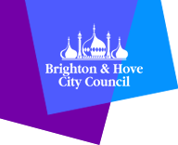
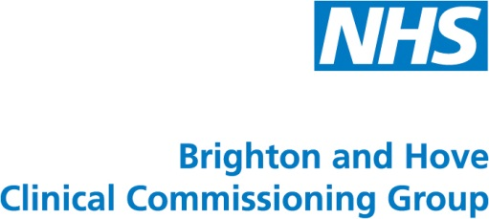
2.30 Close

