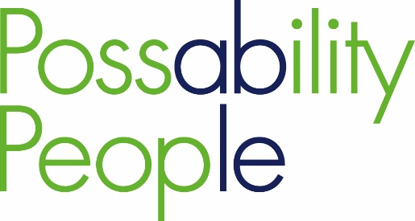
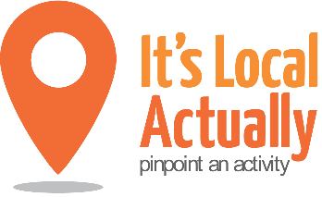

Citywide Connect Programme:
Locality Hub Events: agenda

08.00 Arrivals – breakfast and networking

09.00 Welcome/updates/apologies
Why we are here? – prevention context/vision

09.15 Part 1: Café discussion/conversation points:
- Transitioning from work to retirement
- Bereavement
- Building carer friendly communities
- Digital as a social gateway
- Moving more, ageing well
- Long-term health conditions: a focus on self-care

11.15 Part 2: “Trading Floor” – sharing offers/pledging for action

11.45 Feedback/Next steps

11.50 Monitoring & Evaluation

12.00 Close

