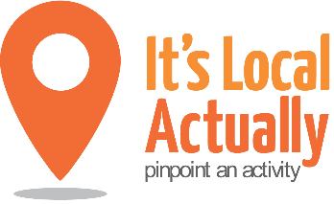
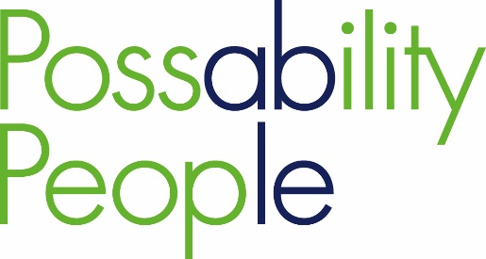

Getting the most out of digital
Vision: That people in later life have the skills to access digital technology in ways that they want

What ‘offers’ do you have and what will you ‘need’ to prevent triggers for loneliness through digital means – helping people in later life have access to:

- digital platforms
- work, education and training opportunities
- private sector services and offers online
- practical support such shopping
- health services and local authority services
- friends/family, social networks/peer support
- information and advice
- low cost and free activities
- information for use when pursuing new hobbies/interests

Transitioning from work to retirement
Vision: That people approaching retirement have opportunities to plan for this transition and can make the most of their time during this stage in their lives

Those finding retirement a positive experience:
- spend more time on hobbies or started new ones
- get more involved in their communities
- have the confidence to try new things and make changes to their lives that would improve their physical and mental health – for example, by taking up some form of exercise, making changes to their diet or learning something new
- are aware of the range of free and low cost activities available
- have enough IT skills to search out what is available
- are aware of the benefits that voluntary work can bring in terms of personal fulfilment and new friendships
- have strategies to help them manage their budgets/finances
- plan their future housing needs eg downsizing/accessibility etc
- have ideas for continuing to generate some income to supplement their pension, for example through part-time work (4.8 million 65 to 70 year olds would like to be working but just 1.2 million currently are)
What ‘offers’ do you have/ what will you ‘need’ to help turn these positive elements into reality for people in retirement

Moving More, Ageing Well
Vision: that people in later life, through maintaining an active lifestyle, live and age well

What ‘offers’ do you have which would help others to ‘make every contact count’ / what would you ‘need’ to:

- highlight the importance of an active lifestyle

- build confidence and motivation through behaviour interventions

- identify impactful programmes in the local community and pathways to access these, including those that improve strength and balance to prevent falls)

- signpost to relevant local activities

- identify engagement opportunities where health and lifestyle advice can be dispensed ‘as standard’

Bereavement Support

Vision: that all people have awareness of and access to support and services throughout their bereavement experience

Preventing loneliness for people who have experienced bereavement goes beyond therapeutic interventions.

What ‘offers’ / ‘needs’ do you have to support people in later life experiencing a bereavement to:

- create new social connections
- develop practical skills, such as cooking, home repairs, dealing with finances
- engage in ‘distraction based’ activities
- access peer support

Long term health conditions: focus on self-care

Vision: For people with long-term health conditions to have support to self-manage these, significantly improving their quality of life, physical and mental health

Due to the varied needs of people with long-term health conditions, prevention initiatives are varied but focus on self-care, through providing:

- Information and advice:
  - helping people understand more about their condition and the services around them (including nutrition advice)
  - enabling access to timely and appropriate support.

- Supporting independence:
  - monitoring their own conditions at home
  - providing adaptations or aids

- Peer support networks:
  - one-to-one support from someone who may have similar life experiences or share a similar condition
  - befriending focusing on a specific outcome
  - support that can help people build and sustain local connections and activity based support

What ‘offers’ or ‘needs’ do you have which would help to enable any of the above?

Carers
Vision: For Brighton and Hove to be a carer friendly community where carers feel supported and recognised as individuals, with needs of their own

Building carer friendly communities involves:
- partners working together to raise the profile of caring
- signposting carers to local support services
- supporting carers to save time and focus on their own health and wellbeing
- empowering carers to take control of their lives eg through informal learning opportunities/career advice/flexible employment and volunteering options
- working in partnership to ensure support is tailored to carers’ needs and fits in with carer time pressures and demands
- support for carers to use online resources to help them manage their health and wellbeing
- developing opportunities for peer support
- understanding more about carers’ key needs at specific transition points ie becoming a carer, bereaved carers, given up caring – (cared for person in hospital/a care home)

What ‘offers’ do you have and what would you ‘need’ for Brighton & Hove to become more of a carer friendly community – incorporating any of the above?

